YOUTH CONTRACT

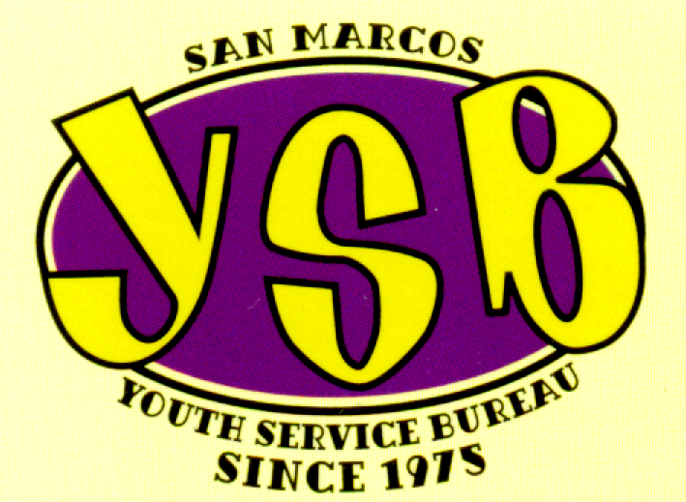

OUR MISSION:
To empower the youth of San Marcos and Hays County communities in becoming contributing members of society as adults.

Youth Information Form

Youth Name: __________________ Age: ______ Date of Birth: _________________

Address: ______________________________ Phone #: ______________________

School: _________________ Grade: ____ Do you skip school? _____ How often______

Personal Information

Please list 3 of your favorite things to do or hobbies: List your best friends:

1. ________________________________ 1.____________________________

2._________________________________ 2. ____________________________

3. _________________________________ 3. ____________________________

Who is the most important person in your life? ___________________________________________

Please describe your family: __________________________________________________________

__________________________________________________________________________________

What do you like best about yourself? ____________________________________________________

What do you like least about yourself? ____________________________________________________

List the important things that have happened in your life: ______________________________________

____________________________________________________________________________________

Do you ever think about hurting yourself? YES NO
Have you ever been abused? YES NO
Do you use drugs or alcohol? YES NO
Do you have concerns about drugs or alcohol? YES NO
Do you think anyone in your family has
problems with drugs or alcohol? YES NO

Describe the last time your family had a good time together: _____________________________________

______________________________________________________________________________________

Any allergies? ________________________________________________________________________

Anything else you would like to say? ________________________________________________________

______________________________________________________________________________________

Who were you referred by: _________________ Date: ________________________

Youth Service Bureau

Non-Discrimination Policy Statement

- I cannot be excluded from YSB programs or services because of my race, ethnicity, sex, national origin, sexual orientation, or physical abilities.

- No information about me will be given to anyone outside YSB without my or my parent/guardian’s written consent.

3. I can expect to be treated with respect by all YSB staff and volunteers, even when I have not been respectful or have broken YSB rules.

4. If I feel my rights have been violated in any way, I can go to any YSB staff or board member with my complaint.

_________________________________________________ _____________________
Youth Signature Date

_________________________________________ __________________
Parent / Guardian Signature Date

_________________________________________________ _____________________
YSB Staff Signature Date

Youth Behavior / Guideline Contract

To keep YSB a safe and fun place, I agree to the following guidelines:

Attendance is required for membership. YSB is a free service offered to the youth of San Marcos CISD with limited spaces available. If you are not using your space, we need to fill it with someone who is able to attend.

Participation is mandatory. Any disruption or lack of participation may result in elimination from the program.

Everyone helps with clean up.

No alcohol, tobacco, other drugs, or weapons are allowed at YSB. Do not come to YSB after using alcohol or other drugs.

No discrimination of any kind will be tolerated. This includes racial slurs, derogatory gender-based comments, or individual exclusion for any reason.

You must get permission to use the computer.

We are a neutral place. Gang symbols, signs, and colors make it less safe for everyone. Do not bring them here or discuss them at anytime.

Ask permission before using the phone.

Seatbelts must be always worn in the van.

If you do not know how to swim you will be asked to not participate in swimming days.

Respect each other’s personal space and property.

If any of these rules are violated the member will be susceptible to a punishment deemed necessary by the program director. Punishments may range from an individual meeting to expelling the member from future YSB programming.

I have read and understand these rules.

________________________________ _______________________
Youth Signature Date

YSB Building Rules

- Watch your language.

- Everyone’s confidentiality is observed;
what is said at YSB stays at YSB.

- The Golden Rule applies: treat others as you wish to be treated.

- No hitting or slapping.

- PICK UP AFTER YOURSELF!

- Wash your dishes.

- All conflicts should be relayed to a staff member.

- Put trash in the trashcans; put recyclables in the recycle bin.

- Respect each other’s space.

- Be careful with the property; it is all of ours.

- Respect each other’s property.

- Do not abuse the rules!

___________________________________ ____________________
Youth Signature Date

___________________________________ ____________________
Staff Signature Date

YSB Code of Character Contract
Modeled after the Rotary 4 Way Test:
- Is it the truth?
- Is it fair to all concerned?
- Will it bring goodwill and better friendships?
- Will it be beneficial to all concerned?

__________________________________ _______________________
Youth Signature Date

__________________________________ _______________________
Staff Signature Date

YSB Policy on Public Display of Affection

The following conduct will not be accepted during youth’s participation at the San Marcos Youth Service Bureau:

- Sitting on top of a person’s lap.
- Hitting buttocks of a person or any other inappropriate touches.
- Laying down underneath tables with other persons.
- Extended kissing, which is a kiss longer than a second (cheek kisses and pecks are appropriate at certain times).

YSB teens are a representation upon the agency itself. Therefore, personal conduct is disciplined when due to not being appropriate for the group as a whole.

YSB code of conduct with appropriateness extends to same sex partners as well as heterosexual.

YSB will not differentiate. All teens will face the certain disciplinary action if there is misconduct among a teen:

- Incident report filled out.
- Day suspension / Parents’ notification of misconduct.
- Indefinite suspension until staff sees otherwise.

YSB teens are very important to the community. Therefore, appropriate conduct is expected. Relationships are encouraged, but inappropriate behavior is not. If you do not understand the following, please feel free to ask any questions.

I, ______________________ understand what has just been read to me. I understand that I am a representation of YSB and that my conduct must be appropriate at all times. I understand that if my behavior is not appropriate the above discipline procedure will be followed.

_________________________________ ____________________________
Youth Signature Date

____________________________ ________________________
Staff Signature Date
YSB Daily Schedule:

4:00 p.m. – 4:30 p.m. Meet, Greet & Eat

4:30 p.m. – 5:00 p.m. Homework, Tutoring or
Journal Writing and then
Youth can use Computer Room

5:00 p.m. – 6:00 p.m. Scheduled Event or Program

6:00 p.m. – 6:15 p.m. Clean Up!

6:15 p.m. – 6:30 p.m. Parents pick up youth!

Summer Hours: Noon - 5:15 p.m.

THANK YOU FOR YOUR PARTICIPATION!

WE ARE GLAD YOU ARE HERE!

CONGRATULATIONS,

YSB STAFF

